**Dietary Tradeoff System**

Final Project Report – Fall 2016

Submitted by:

Rong Zeng

Nirmala Seshadri

Saketh Patibandla

Akshay Kumar Vikram

Thushara Elizabeth Tom

**BIA 650 – OPTIMIZATION AND PRocess Analytics**

Prof. Edward A. Stohr

**Table of Contents**

Abstract: 3

Problem with existing system: 3

Introduction: 5

Pareto analysis: 6

Tradeoff curves: 8

Data generation: 9

IBM Watson: 10

Dietary Tradeoff System: 10

A) Nutrient selection: 11

B) Recipe selection: 12

C) Recipe tradeoff and analysis: 13

Scope and Improvement: 14

Conclusion & Recommendation: 16

References: 16

Appendix A: 17

**Table of Figures**

Figure 1: A brief Introduction of the Dietary Tradeoff System 6

Figure 2: To maximize Objective 1 and 2 8

Figure 3: To maximize Objective 1 and minimize Objective 2 8

Figure 4: Nutrition Facts of a food item with serving size of 89.5 gm 9

Figure 5: Criteria selection page selecting 4 nutrients 12

Figure 6: Overview of the available recipes with required nutrients 13

Figure 7: A tradeoff to analyze the best recipe to choose from 14

# Abstract:

Food is a major part of life and a person’s health depends on how well they eat. A person has himself to blame for irregularly taken meals and an imbalanced diet. To provide people with a choice to choose their recipe with nutrients of their choice would be something that makes them not only conscious but also put them in control of what they would like to eat. This has been a major problem in the past due to no options of analysis or lack of information available to them. In this paper, Dietary Tradeoff system, a tool is explained which was developed using Watson Analytics that allows people to pick their recipe based on their requirement of maximizing or minimizing nutrient intake and incorporates Pareto Optimization to select a recipe based on the nutrient that is most needed or one which user might want to avoid consumption of, with the assistance of graphs showing tradeoff between chosen recipes. With the availability of this model, a person has can plan their meal from a set of 198 recipes which contain nutrients best suited to their dietary requirement. A use of Pareto analysis is something that is not very new and is used in many situations in our daily life and the thought that food and health might be a best fit is what drove this approach forward to create this model.

# Problem with existing system:

Children are getting overweight faster in this generation more than before, the NIH (the National Institute of Diabetes and Digestive and Kidney Diseases) overweight and obesity statistics states that two-thirds of the people are overweight and a third of the total population are obese, more than one in 20 adults has extreme obesity, about a third of the children between 6 and 19 are overweight or obese [from V]. This situation doesn’t look good. With fitness, health and nutrition making a huge impact in the current world, the problem is that people need to identify what the factors are to have a satisfying meal and concentrate on their body, as the saying goes, a good mind is the result of a good body which can only be achieved with a proper diet. Even with a proper diet, a human being is not able to understand how things don’t work out and what goes wrong when it comes to maintaining a good physique or getting to a shape which one wants to get to. EUFIC Review from April/2005 has talked about the major determinants of one’s food choices. Although, there exist external and availability factors like hunger, palatability, they also need to have a clear education on what they want to eat and why it does them benefit or harm [from II]. It also speaks about how people do not understand the portion sizes of their meal and helping them would be easy by letting them know the volume they consume with each meal, how the calorie content and nutrients that come behind packaged food and snack would help when making a dish using a recipe. Cooking food using a recipe might decrease the nutrients but it is mostly not very significant [from III]. So, if cooking is done after careful consideration of what ingredient has how much nutrients, it makes food an enjoyable and beneficial experience. People do not follow healthy eating and the fitness magazine states that healthy eating and following diet plans is the sole way of making people reach their target irrespective of how much they work out or avoid eating altogether. People should be choosing more vegetables, fruits, whole grains, switching to low fat milk, eating good protein in food, checking sodium contents so that it doesn’t affect the body and reduce the amount of sugar and direct body fats. Also, portion sizes should be controlled, one shouldn’t force feed when they are full [from IV].

People do not monitor their progress and in a world ridden with technology, smart phones and watches, health and fitness aren’t being kept under check. They should find a way to utilize everything that is available to them and one way to make an improvement to the current crop of technology is the Dietary Tradeoff. Only, the system will not be of much help without a manual choice. Also, health is a major aspect of food choices, concern over health has a direct impact on what people eat. Suppose, an overweight person chooses different food compared to someone with an impressive metabolism. Calorie count and fat content are some of the most important aspects to be checked while selected what to eat [from VI].

# Introduction:

The goal of this project is to help health conscious people plan their meals in advance. The Watson Dietary Tradeoff system is a tool targeted at health-conscious people, who like to plan their meals in advance. It enables the user to obtain a shortlist of recipes relevant to their input of nutrient needs. An optimal mix of recipes fulfilling the user’s planned diet will be generated by this tool which stimulates the user’s decision making process to select the one recipe for a meal, from an original database of 198 recipes.

The following flow chart explains the basic flow of steps undertaken to create the Watson Dietary Tradeoff Tool. Data is scraped [from I] using R. The result is converted into a JSON format and prepared for loading into the IBM Bluemix Tradeoff Analytics service. A JSON problem object is created on the Watson platform to define the decision problem and options. This problem object is then sent to the Watson Tradeoff Widget for programming the details of the decision criteria and the available nutrient options. This then serves as the base for the Dietary Tradeoff interface available to the user.

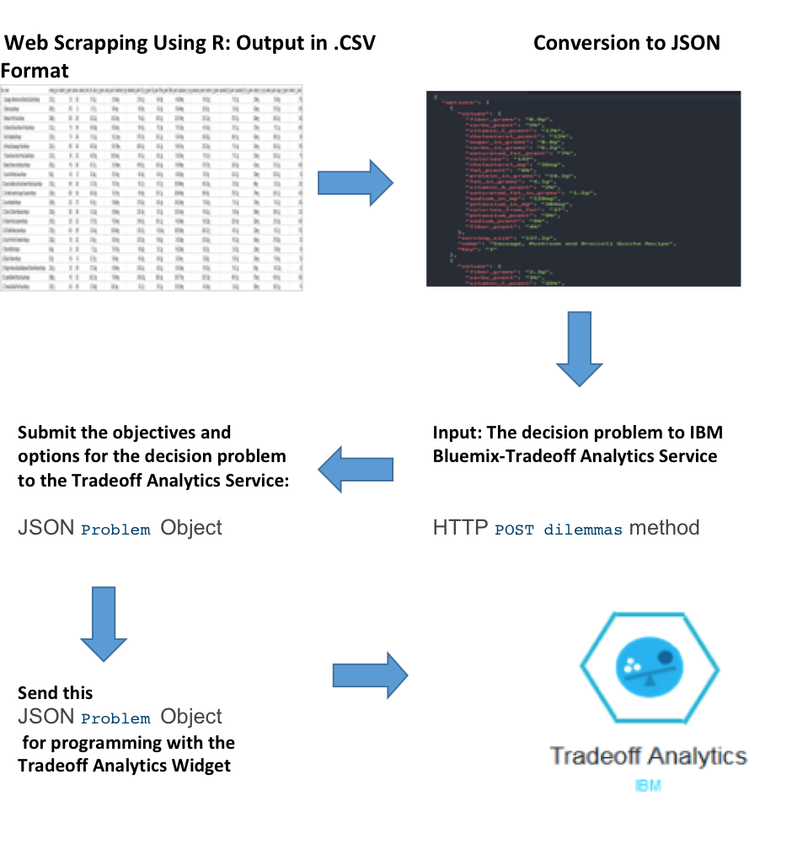

Figure 1: A brief Introduction of the Dietary Tradeoff System

# Pareto analysis:

The term came from an Italian economist, Vilfredo Pareto who wanted to find theories in microeconomics, land distribution and maintain economy changes in his nation. A Pareto efficient situation occurs when there is no outcome that makes one person better off without making the other worse-off. This means that if there is a condition that a problem can be improved or an efficient solution should be found to a problem, it can be found solved with a Pareto efficiency condition with improvement from one participant which in turn results in the downfall of the second. To describe this better, let us take X and Y, which are two players in an optimality problem. X is Pareto inefficient or suboptimal when no one prefers X and at least one prefers Y [from VIII], Pareto efficient conditions are formed on assumptions that while people choose conditions to improve themselves, they prefer cheaper, reliable and efficient methods.

With this we can talk about Pareto improvement, which is the way to distribute goods in a system based on Pareto efficiency. Here, Pareto improvement is said to be achieved when a normal non-optimal situation is brought to a state of optimality. A Pareto improvement is not possible if a system reached optimality or that it is impossible to improve the situation of an individual without causing harm to another [from IX]. In a HR environment, let’s say a person has two teams to run a business that work on different phases in a single project, the first team has 16 people and the second 10. Now, the first team has almost finished its deliverables and are overstaffed. The second is lagging and are need someone with the skillset of the first team players, now if this situation is a Pareto efficient situation. The second team can only benefit by getting a person turn from Team 1 to the second team.

Some examples of Pareto in real life are stated below.

* Instead of having one meal that fills you up completely, have four meals that make a good nutritional value and may keep you content.
* It is better to choose a couple of good articles to read in 5 hours and gain knowledge after skimming through 15 and choosing them rather than reading all 15 and not being able to correctly figure them out. [from X]
* Sometimes, while choosing a job, people do not always choose what they like or what their hobby is, they choose what they’re good at, and see it as a source of learning.

Sometimes, a Pareto optimal situation is also best known as the 80/20 where it clearly states that almost everything in life is unevenly distributed. Originally started by Pareto to show that 80% percent of Italy’s wealth is with 20% of the population, this rule talks about some interesting facts that most of the revenue is created by a small crop of users, a small but efficient input creates most of the result, in software most of the programs crash due to a small number of bugs, etc.

# Tradeoff curves:

Tradeoff curve or (the efficient frontier) and Pareto optimality in a multi objective situation go hand in hand. In a Pareto-optimal situation, there exist more than one feasible solution or to state more clearly, there are at least N solutions for an N way objective problem. Let us consider a multi objective problem with two feasible solutions A and B that can be used to solve it. We can have a graphical approach to this problem [from XVI].

In the below situation, our objective is to maximize both Objective 1 and Objective 2, the graph bounded by the region between A and B is the set of dominated solution and the upgrade to them are points on the bounded curve which is called as the tradeoff curve. To improve objective 1, B is traded off and vice versa.

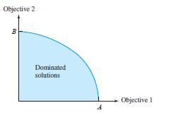

Figure 2: To maximize Objective 1 and 2

Similarly, we can also apply the same technique for a maximization-minimization problem. Below is an open region between A and B to show that both criteria are met in the problem.

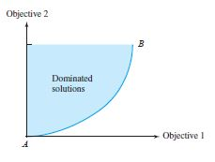

Figure : To maximize Objective 1 and minimize Objective 2

# 

# Data generation:

A database of recipes was created for the IBM Watson Trade-Off Analytics system. This contains the names of recipes and the accompanying nutrient measures per recipe. www.caloriecount.com was selected as the data source for the project. [www.caloriecount.com](http://www.caloriecount.com/) is a website that consists of recipes and food labels for a health-conscious individual. It contains details of the food nutrients, size of servings and the grams per size in the form of fact tables under the recipes and food products. The nutrition fact table as shown below is available for each of the recipes on the website.

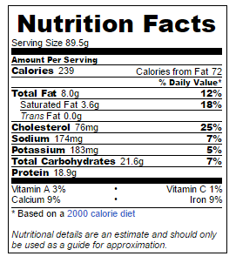

Figure 4: Nutrition Facts of a food item with serving size of 89.5 gm

For extracting the required information from the website, we made use of R and the RSelenium package. R is a data analysis tool that can be used for statistical computing and graphics. It is open source software and one of its main advantages, is its ease of utilization. It has numerous functionalities and each of its functionalities is enclosed in different packages.

RSelenium is a package used to drive the webserver. It makes it easier to connect to the Selenium server/Remote Selenium Server from within R. Using RSelenium, the server was connected to the browser and the website was accessed. The package went through to the list of recipes page and clicked the link to each recipe. Once in a single recipe page, Selenium package would scroll down to each fact table at the bottom of the page and scrape the required values. For our project, we have scraped the values of Name of Recipe, Serving Size, Percentage of Vitamin A, Calories, Calories from fat, Carbs in grams, Carbs in Percentage, Cholesterol in grams, Cholesterol in percentage, Fat in grams, Fat in Percentage, Fiber in grams, Fiber in Percentage, Potassium in grams, Potassium in percentage, Protein in grams, Saturated fat in grams, Saturated fat in percentage, Sodium in grams, Sodium in percentage, Sugar in grams and Vitamin C in percentage. The data was scraped for a hundred and ninety-eight recipes. The scraped data is saved in the form of a csv file from R. The csv file was later run through a python script to generate a json file. The json file will serve as the final input file to IBM Bluemix.

# IBM Watson:

Named after the first CEO of IBM, Thomas J. Watson, it is an interactive technique using natural language processing that answers questions while selecting a product or requirement on the web. It was developed in IBM’s DeepQA project where a human and machine started to develop a relationship using deep learning [from ref. XIII]. The Decision Problem is setup and is fed to the Tradeoff Analytics API and the User can provide their criteria with the Interactive Interface. The underlying optimization mechanism for Watson Tradeoff Process is the mathematical filtering technique of **Pareto Optimization** which is discussed above. It enables users to explore tradeoffs when considering multiple nutrient criteria for a single decision of what recipe is the best for the defined criteria.

# Dietary Tradeoff System:

After the data is fed to the IBM Watson Tradeoff analytics API, by means of the working in the IBM Bluemix, a cloud based platform to develop applications on the web[ from ref XII], the Dietary Tradeoff System is created and is run on the url ‘**tradeoff-analytics-akshaykumarvikram.mybluemix.net**’. The process of allowing the users choose their meal using this model is mainly carried out in 3 different steps:

A: Finding the most suitable recipe option, out of many possible options dependent on the nutrient criteria.

B: Graphically presenting these recipe options and the tradeoffs among the nutrients for these top recipes.

C: Simulating human judgment to guide the user through selecting the best recipe

# Nutrient selection:

This is the first phase of the model, in this the user selects nutrients from which they would like their recipe to be selected. Users are given a choice of maximizing or minimizing a nutrient to select their recipe. For example, a person who wishes to improve muscle mass would want to consume high calorie and protein content while a person looking to lose weight rapidly doesn’t want high calories in his food, while a healthy person, who wants a balanced meal wants a rich combination of nutrients and varies meals all the time. For this reason, a choice is included. A minimum of three nutrients are to be included as there are very few meals that constitute only two nutrients and further a tradeoff cannot be performed on them.

Input: Nutrients (3-10)

Output: Recipes constituting nutrients selected.

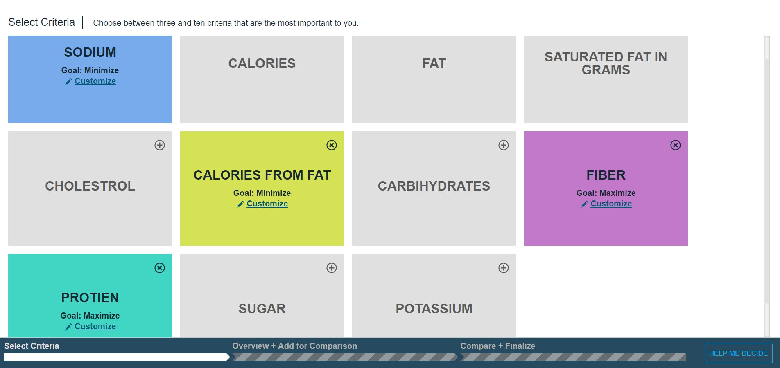

Figure 5: Criteria selection page selecting 4 nutrients

# Recipe selection:

After the nutrients are defined and the users wants to see which food is best suit for the them, we enter the second phase which lets them choose the recipes they would like to choose based on a composition of all the nutrients of their choice. A filter is provided to set the quantity upper and lower limits to classify the recipes further and dig out ones that really meet their cause. While filtering out the nutrient levels, the number of choices reduce in the graph and on the header of where the names of the food are present. The meal can be chosen either by clicking the graph icon representing the percentage of the nutrient contained and is placed closest to the nutrient objective, for example if a maximization requirement is selected for fiber, the graph icon representing food with the highest fiber content appears closest to ‘FIBER’ and vice versa. The meal can also be chosen by selecting the ‘plus’ symbol before the name of the item. Now, that the recipe has been chosen, comparison is made in the next step.

Input: Selected recipes.

Output: Tradeoffs between the food items.

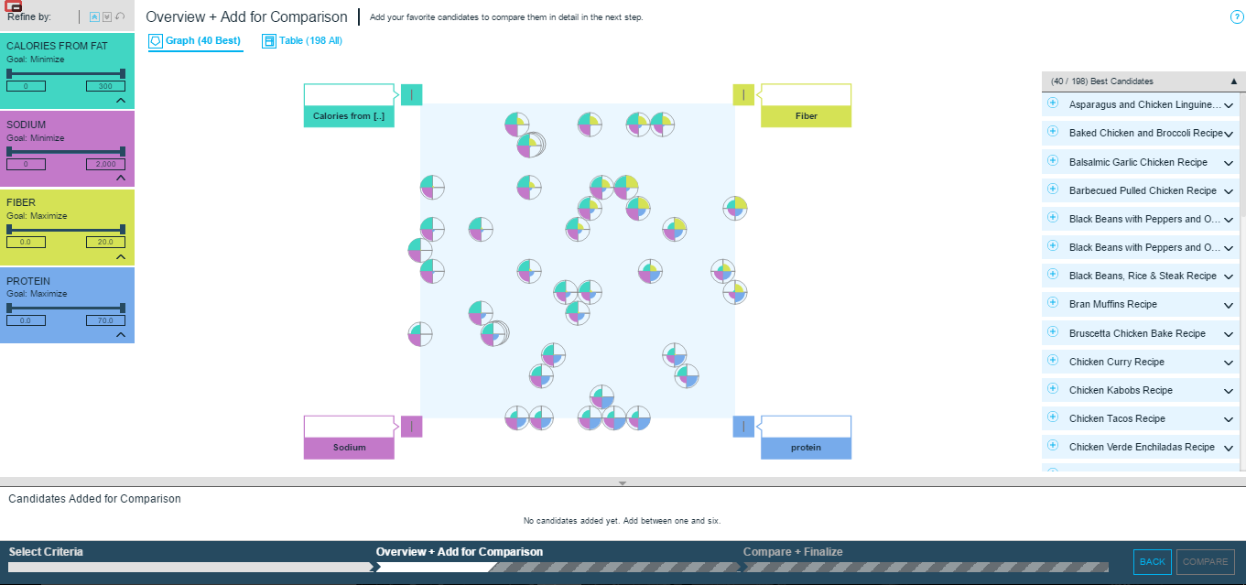

Figure 6: Overview of the available recipes with required nutrients

# Recipe tradeoff and analysis:

After a list of recipes are selected and now the user arrives at the destination where a final recipe should be selected so that he gets to eat his meal for the session and continue his work. After the choices are made, the user is left with a dilemma and a set of tradeoff lines with percentages in front of him that will help deciding. This is the last phase where all the meals selected are compared based on nutrient values and little differences that might be pivotal in helping the user choosing a recipe.

Let us assume that two choices of recipes were selected, the first one has 45% protein, 11% fiber, 40% calories and 4% percent sodium and the other recipe chosen to compare has 20% protein, 45% fiber, 30% calories and 5% sodium. As it can clearly be seen, there is not a significant difference in sodium content and it does not play a role in the User’s choice. Now, a person who wants to develop his body will choose the first recipe and the person who would want a high fiber intake to purify his bloodstream and digestive system takes the second although it has low protein. This way, protein is traded off for fiber by choosing the second recipe. Coming back to the system, it generates a tradeoff analysis between the nutrients for all the recipes selected and makes it easy for the user to plan a meal. Here, the nutrients represented in ‘red’ are father to the goal and ones marked in ‘green’ are closer to the goal. The User gets to make a final choice and clicks on ‘DONE’ after finalizing what his meal is going to be.

Input: Various recipe choices with tradeoff curves.

Output: One final recipe choice.

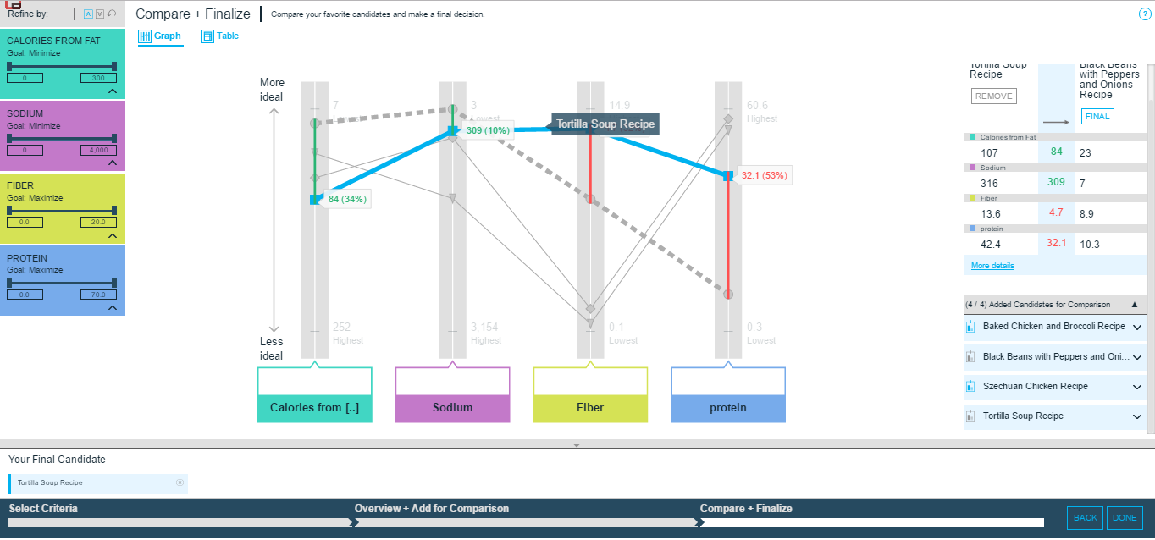

Figure 7: A tradeoff to analyze the best recipe to choose from

# Scope and Improvement:

As the model is in its infancy stage, there are some shortcomings that need to be improved. A detailed plan has been made for the future development. In this plan, further work will be segregated and carried out in three parts.

First, the number of recipes in our system need to increased. There are only a hundred and ninety-eight recipes in it and they are not enough to meet the needs of the users. Most recipes in the current system are recipes of American food and customized American food and some of our users are not native American or do not enjoy American food. They could also be vegetarian and might not have an affinity to meat or can possess a strong dislike. While doing this review, taste factor was never considered and should be a part of the next step. They may come from India, China, Spain, Mexico, etc where food is different. Hence, it is important to add these country’s recipes into our database. New recipes are on the food websites of these countries. The motive is to expand the recipe database to at least a thousand recipes in the future.

Secondly there is no scenario to check prices in the system currently, so a new technique to incorporate price criteria in the decision problem should be added. A database of the costs of making the recipes based on its ingredients are created. If users are price sensitive, they will save more money without reducing nutrition. In order to achieve such a goal, a real-time update for the food sales website needs to be found or should work with a third-party site such as Walmart, Amazon or Shoprite. If this can be done, it will save us a lot of time and cost and the users will not put so much effort into this.

Another expansion would be to add a customized fitness program based on inputs from the user regarding expectation from the workout like calories, different flavors to choose and time willing to spend. These functions will provide more options to customers. Maybe some people do not like to spend too much time on cooking. If the cooking time is recorded in our database, users can be told about the details of how much time they need to cook the dish. If they want to eat some sweet or spicy food, they can choose their taste preference for that is specific to them. The customized fitness program will make our system more competitive and will be the users’ favorite.

# Conclusion & Recommendation:

This model is primarily targeted for diet conscious people who like to keep track of their nutrient intake and plan their meals accordingly.

The team has put in a lot of effort to successfully build the Dietary Tradeoff System using IBM Watson Analytics platform. Although it is in its initial stages now, the system will be improved more functions will be added in the future.

The plan is to create a practical and competitive product to meet users’ need for delicious cooking. When we look at a field of a cooking application, there aren’t many mature, popular and competitive products. Therefore, our Dietary Tradeoff System has great potential in the future.

# References:

I <http://www.caloriecount.com>

II [The](http://www.eufic.org/article/en/expid/review-food-choice/) determinants of food choice [EUFIC Review 04/2005]

III <http://authoritynutrition.com/cooking-nutrient-content/>

IV <http://www.fitness.gov/eat-healthy/how-to-eat-healthy/>

V[https://www.niddk.nih.gov/health-information/health-statistics/Pages/overweight-obesity- statistics.aspx](https://www.niddk.nih.gov/health-information/health-statistics/Pages/overweight-obesity-%20statistics.aspx)

VI <https://www.leaf.tv/articles/6-factors-that-influence-our-food-choice>

VII <https://www.entrepreneurs-journey.com/397/80-20-rule-pareto-principle/>

VIII <https://www.britannica.com/topic/Pareto-optimality>

IX <http://www.economyprofessor.com/pareto-optimality-1906>

X<http://economistsview.typepad.com/economistsview/2015/12/on-pareto-optimality.html>

XI<https://betterexplained.com/articles/understanding-the-pareto-principle-the-8020-rule/>

XII IBM Bluemix Platform - www.ibm.com/bluemix-platform‎

XIII <https://www.research.ibm.com/deepqa/deepqa.shtml>

XIV <https://www.r-project.org/about.html>

XV <https://cran.r-project.org/web/packages/RSelenium/vignettes/RSelenium-basics.html>

XVI Practical Management Science [Winston & Albright – Edition 4]

# Appendix A:

Recipe data used for Dietary Tradeoff system: (Sample for 4 nutrients and 100 recipes with normalized amount of serving sizes)

|  |  |  |  |  |  |
| --- | --- | --- | --- | --- | --- |
| **Name of the Recipe** | **Serving_size** | **Vit_A** | **Calories** | **Calories_Fat** | **Carbs** |
| Sausage, Mushroom and Broccoli Quiche Recipe | 137.2g | 2% | 142 | 37 | 6.2g |
| Skinny Soup Recipe | 249.7g | 37% | 51 | 8 | 7.7g |
| Mexican Pita Pizzas Recipe | 180.0g | 10% | 230 | 56 | 32.2g |
| Chicken & Broccoli Bow-Tie Pasta Recipe | 131.1g | 7% | 196 | 40 | 24.8g |
| Keri's Meatloaf Recipe | 155.5g | 7% | 246 | 71 | 16.1g |
| Shrimp & Asparagus Pasta Recipe | 216.7g | 29% | 244 | 48 | 25.4g |
| Chicken Bacon Ranch Pasta Salad Recipe | 133.7g | 8% | 223 | 46 | 29.5g |
| Baked Chicken and Broccoli Recipe | 305.2g | 9% | 356 | 83 | 7.5g |
| Low Fat Alfredo Sauce Recipe | 98.2g | 6% | 92 | 32 | 6.6g |
| Savory Golden Lentil and Sweet Potato Soup Recipe | 191.5g | 34% | 160 | 15 | 19.7g |
| Tex-Mex Summer Squash Casserole Recipe | 220.4g | 82% | 196 | 86 | 20.3g |
| Lean Meatloaf Recipe | 169.9g | 22% | 179 | 45 | 9.5g |
| Claire's Chicken Mexicana Recipe | 230.0g | 10% | 184 | 31 | 16.3g |
| Chicken Pasta Casserole Recipe | 187.0g | 12% | 233 | 57 | 19.7g |
| Jill's Beef Barley Stew Recipe | 272.0g | 41% | 299 | 31 | 44.1g |
| Crock Pot Pork Tenderloin Recipe | 202.0g | 0% | 182 | 52 | 4.6g |
| Bran Muffins Recipe | 66.6g | 1% | 100 | 7 | 21.1g |
| Dijion Chicken Recipe | 50.5g | 0% | 43 | 32 | 1.9g |
| Ginger-Honey Glazed Barbecued Chicken Breasts Recipe | 134.1g | 0% | 249 | 37 | 16.4g |
| Loaded Baked Potato Soup Recipe | 368.6g | 9% | 323 | 163 | 21.4g |
| Tomato & Basil Pita Pizzas Recipe | 129.7g | 11% | 199 | 15 | 38.0g |
| Garlic Herb Crusted Chicken Recipe | 154.5g | 4% | 362 | 81 | 31.1g |
| Broccoli Cheese Soup Recipe | 390.7g | 55% | 302 | 180 | 14.5g |
| Crab Cakes Recipe | 69.1g | 2% | 98 | 32 | 10.4g |
| Chicken Fried Rice Recipe | 171.5g | 2% | 241 | 75 | 23.9g |
| Asian Tuna Patties Recipe | 90.2g | 4% | 145 | 55 | 3.8g |
| Low Cal Chicken Burrito with Veggies Recipe | 215.0g | 13% | 208 | 30 | 17.1g |
| Szechuan Chicken Recipe | 233.8g | 4% | 331 | 56 | 10.4g |
| Stuffed Peppers Recipe | 332.8g | 14% | 222 | 46 | 24.0g |
| Chicken Enchiladas Recipe | 140.2g | 9% | 272 | 140 | 18.5g |
| Chicken Pot Pie Recipe | 113.6g | 2% | 150 | 45 | 17.7g |
| Garlic Shrimp Pasta Recipe | 268.0g | 94% | 288 | 47 | 31.6g |
| Chicken Wrap Recipe | 180.6g | 9% | 233 | 76 | 10.2g |
| Black Beans with Peppers and Onions Recipe | 193.4g | 42% | 200 | 23 | 36.4g |
| Mozzarella Chicken Recipe | 234.2g | 8% | 308 | 55 | 30.5g |
| Aloha Chicken Recipe | 176.0g | 3% | 290 | 36 | 32.4g |
| Pesto Recipe | 21.9g | 11% | 63 | 50 | 1.8g |
| Delicious Skillet Chicken Recipe | 610.2g | 113% | 353 | 119 | 22.3g |
| Black Beans with Peppers and Onions Recipe | 193.4g | 42% | 200 | 23 | 36.4g |
| Mozzarella Chicken Recipe | 234.2g | 8% | 308 | 55 | 30.5g |
| Aloha Chicken Recipe | 176.0g | 3% | 290 | 36 | 32.4g |
| Pesto Recipe | 21.9g | 11% | 63 | 50 | 1.8g |
| Delicious Skillet Chicken Recipe | 610.2g | 113% | 353 | 119 | 22.3g |
| Spinach and Feta Pasta Recipe | 199.9g | 101% | 327 | 127 | 37.2g |
| Lasagna Roll-Ups Recipe | 231.9g | 79% | 289 | 58 | 40.2g |
| Sloppy Joes Recipe | 257.5g | 40% | 397 | 56 | 47.8g |
| Beef Stroganoff Recipe | 194.7g | 9% | 191 | 58 | 12.8g |
| Kona Chicken Recipe | 163.3g | 2% | 244 | 31 | 18.3g |
| Parmesan-Seared Chicken Recipe | 131.9g | 1% | 187 | 63 | 0.7g |
| Chicken Breast Recipe | 169.5g | 12% | 221 | 39 | 5.8g |
| Cuban Mojo Chicken Recipe | 175.8g | 5% | 286 | 96 | 3.9g |
| Beef Broccoli Stir-Fry Recipe | 133.5g | 11% | 164 | 65 | 5.9g |
| Meaty Biscuit Cups Recipe | 55.1g | 1% | 125 | 48 | 9.3g |
| Grilled Shrimp Salad Recipe | 170.1g | 8% | 74 | 8 | 3.6g |
| Spicy Tuna and Egg Salad Recipe | 129.4g | 1% | 176 | 45 | 7.0g |
| Favorite Crockpot Chili Recipe | 177.9g | 17% | 304 | 40 | 36.7g |
| Stuffed Cabbage Recipe | 311.0g | 14% | 230 | 63 | 27.4g |
| Ratatouille Recipe | 440.5g | 42% | 262 | 132 | 21.8g |
| Toni's Chicken Brocolli Quiche Recipe | 132.0g | 12% | 177 | 54 | 9.5g |
| Guilt Free Blueberry Pancakes Recipe | 264.4g | 13% | 149 | 14 | 17.6g |
| Easy Hamburger Casserole Recipe | 344.6g | 1% | 290 | 87 | 23.4g |
| Tomato Spinach Soup Recipe | 333.7g | 64% | 79 | 23 | 11.8g |
| Chicken Chili Recipe | 310.5g | 43% | 190 | 23 | 28.7g |
| Parmesean Chicken Recipe | 224.0g | 2% | 421 | 113 | 12.6g |
| Jessicas Cheesy Chicken Recipe | 121.8g | 7% | 301 | 148 | 5.7g |
| Barbecued Pulled Chicken Recipe | 257.0g | 0% | 312 | 18 | 36.9g |
| Low Fat Glazed Chicken in The Crockpot Recipe | 154.4g | 3% | 243 | 37 | 13.3g |
| Moosewood's Very Creamy Potato-Cheese Soup Recipe | 516.8g | 62% | 426 | 252 | 30.0g |
| Pork Chops with Mustard and Marmalade Recipe | 180.4g | 2% | 184 | 64 | 7.3g |
| White Beans & Greens Recipe | 282.9g | 28% | 142 | 40 | 19.4g |
| Chicken Kabobs Recipe | 150.8g | 15% | 183 | 31 | 2.8g |
| Sweet and Sour Chicken Recipe | 299.1g | 34% | 215 | 36 | 26.9g |
| Herbed Mushroom Round Steak Recipe | 186.2g | 0% | 300 | 131 | 3.3g |
| Turkey Meatballs Recipe | 70.0g | 1% | 104 | 47 | 2.2g |
| Shrimp Pasta Recipe | 369.4g | 48% | 389 | 105 | 59.8g |
| Garlic Round Steaks with Vegetables Recipe | 280.9g | 25% | 248 | 57 | 11.3g |
| Sherry's Chicken Roll Up Casserole Recipe | 319.0g | 31% | 608 | 206 | 58.7g |
| Cajun Pork Chops Recipe | 117.6g | 20% | 194 | 51 | 1.6g |
| Light Chicken Parmesan Recipe | 294.4g | 42% | 146 | 43 | 10.5g |
| Shauna's Lentil Soup Recipe | 321.7g | 79% | 138 | 19 | 22.3g |
| Grilled Chicken Breast Sandwich Recipe | 196.0g | 11% | 212 | 34 | 14.2g |
| Ranch Chicken Recipe | 121.9g | 3% | 320 | 165 | 7.6g |
| Claire's Black Bean and Beef Chili Recipe | 226.6g | 19% | 294 | 32 | 41.0g |
| Crock Pot Stuffed Peppers Recipe | 305.4g | 15% | 264 | 95 | 19.0g |
| Sesame Chicken Recipe | 284.7g | 12% | 195 | 56 | 10.7g |
| Chicken Verde Enchiladas Recipe | 239.4g | 18% | 288 | 32 | 30.3g |
| Tortilla Soup Recipe | 480.4g | 187% | 401 | 107 | 34.9g |
| Parmesan Crusted Tilapia Recipe | 153.3g | 10% | 237 | 105 | 6.9g |
| Turkey Meatloaf Recipe | 82.9g | 5% | 148 | 64 | 5.6g |
| Tuna Casserole Recipe | 126.8g | 2% | 147 | 57 | 13.1g |
| French Toast Recipe | 53.5g | 3% | 76 | 30 | 6.8g |
| No Noodle Zucchini Lasagne Recipe | 260.0g | 30% | 254 | 83 | 12.7g |
| Tuscan Chicken Recipe | 388.3g | 63% | 386 | 106 | 26.7g |
| Garlic and Lemon Tilapia Recipe | 183.9g | 68% | 161 | 10 | 9.0g |
| Italian Stuffed Zucchini Recipe | 344.9g | 11% | 294 | 127 | 18.8g |
| Chicken, Tomato, Bean Crock Pot Soup Recipe | 399.4g | 28% | 260 | 41 | 27.5g |